**PIZZA SALES SQL QUERIES**

**A.KPI’s**

**1.Total Revenue:**

select sum(total_price) as Total_Revenue from pizza1

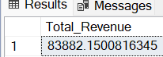

2.Average

select sum(total_price)/count(distinct order_id) as Avg_Order_Value from pizza1

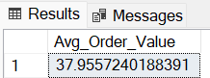

3.Total Pizza Sold

select sum(quantity) as Total_Pizza_Sold from pizza1

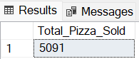

4.Total orders

select count(distinct order_id) as total_orders from pizza1

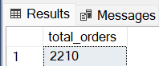

**5.Average Pizzas per order**

SELECT CAST(cast(SUM(quantity) AS DECIMAL(10, 2))/CAST(COUNT(DISTINCT order_id) AS DECIMAL(10, 2)) AS DECIMAL(10, 2)) AS Av_Pizzas_Per_order from pizza1

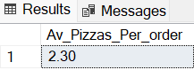

**Charts requirments**

**1.Daily trends**

SELECT DATENAME(DW, order_date) as order_day, COUNT(DISTINCT order_id) AS Total_orders from pizza1

GROUP BY DATENAME(DW, order_date)

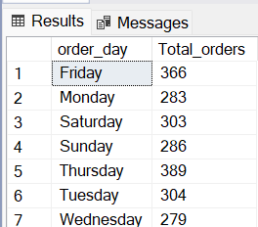

**2. Monthly trends**

SELECT DATENAME(MONTH, order_date) AS Month_Name, COUNT(DISTINCT order_id) AS Total_Orders FROM pizza1

GROUP BY DATENAME(MONTH, order_date)

ORDER BY Total_Orders DESC

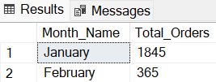

**3.Percentage**

SELECT pizza_category, sum(total_price)*100/( SELECT sum(total_price) from pizza1) AS PCT from pizza1

GROUP BY pizza_category

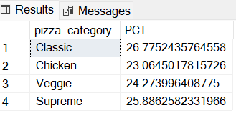

**4.Total pizzas sold by pizzas category**

SELECT pizza_size, CAST(sum(total_price) as decimal(10,2)) as Total_Sales, CAST(SUM(total_price)*100 / (SELECT SUM(total_price) from pizza1 WHERE DATEPART(QUARTER, order_date)=1

) AS DECIMAL(10, 2)) AS PCT from pizza1

WHERE DATEPART(QUARTER, order_date)=1

GROUP BY pizza_size

ORDER BY PCT DESC

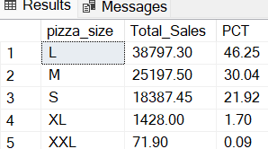

**5.Top 5 pizza by revenue**

SELECT TOP 5 pizza_name, sum(total_price) as Total_Revenue from pizza1

group by pizza_name

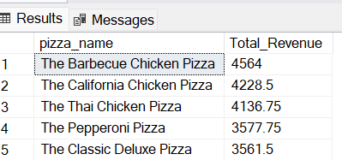 ORDER BY Total_Revenue DESC

**6.Bottom 5 pizza by revenue**

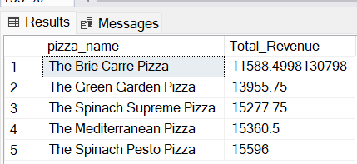

7.Top 5 basis on quantity

SELECT TOP 5 pizza_name, sum(total_price) as Total_Revenue from pizza1

group by pizza_name

ORDER BY Total_Revenue ASC

